***Round-5 by Team PLEO_IT&ANALYTICS***

**Tableau Round**

1. **Forecast the data using the months and closing price. (3 months forecasting is fine and explain in the word file)**

**Options Used to Create Forecasts**

|  |  |
| --- | --- |
| **Time series:** | Month of Month |
| **Measures:** | Sum of Close Price |
|  |  |
| **Forecast forward:** | 13 months (December 2021 – December 2022) |
| **Forecast based on:** | April 2016 – November 2021 |
| **Ignore last:** | 1 month (December 2021) |
| **Seasonal pattern:** | None (Searched for a seasonal pattern recurring every 12 Months) |

**Sum of Close Price**

|  |  |  |  |  |  |  |  |  |  |  |  |  |
| --- | --- | --- | --- | --- | --- | --- | --- | --- | --- | --- | --- | --- |
| **Initial** | | |  | **Change From Initial** |  | **Seasonal Effect** | |  | **Contribution** | |  |  |
| **December 2021** | | |  | **December 2021 – December 2022** |  | **High** | **Low** |  | **Trend** | **Season** |  | **Quality** |
| 745.4 | ± | 11.0% |  | 11.5% |  | None | |  | 100.0% | 0.0% |  | Poor |

The estimate for the year 2022 is mentioned below.

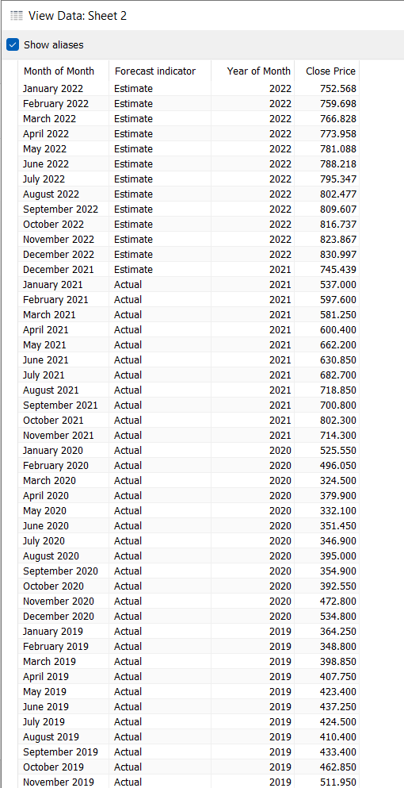

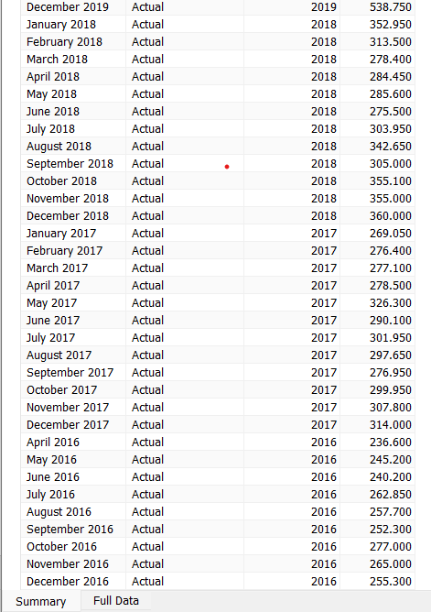

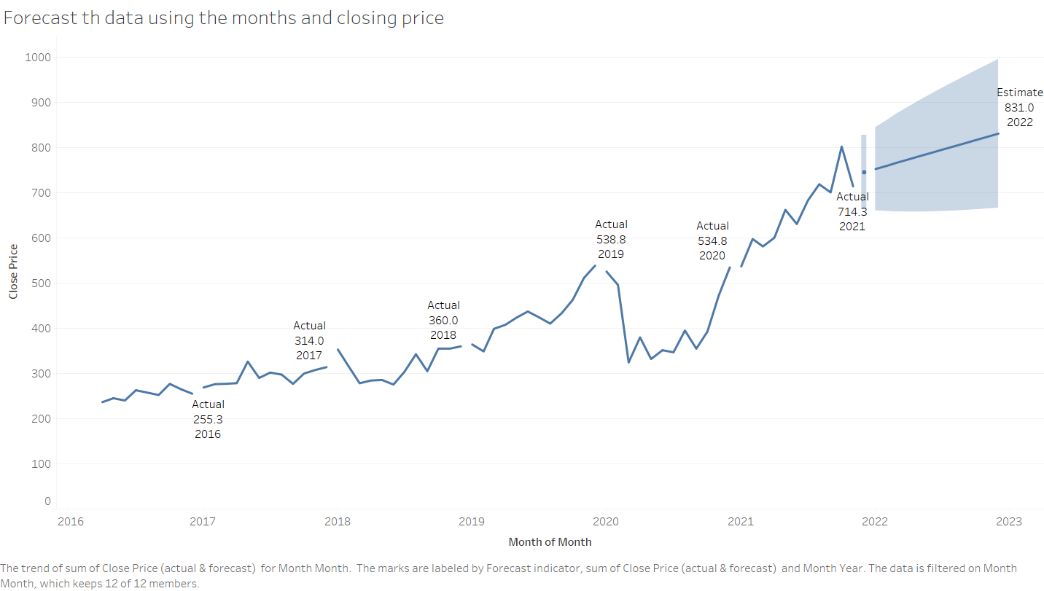

**Insights:**

* Trend line is created for close price and month of month from 2016 to 2023.
* Then the forecast is made for next 3 months which is visible in the above graph as well as table.
* The curve is straight which indicates the growth is linear.
* The actual amount as of 2021 is 714.3 Million $ and the estimated is 831 Million$ in 2022.
* The graph is moving upwards, which indicated the positive impact on the company for the year 2022.
* The increase is observed as 16.4% for the year 2022.

**2.Visualize the data in tableau by taking minimum 3 key metrics and explain about it in the word file.**

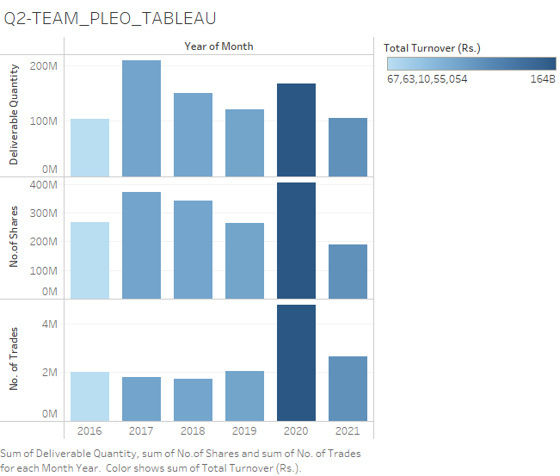

**Insights:**

* Used colour shade to differentiate the values from 2016 to 2021
* In year 2020 the shade is dark which indicates that maximum quantity trades and shares has been transacted.
* Similarly in 2016 the shade is light that indicates the low transaction of three metrics